**Practical: 1**

**Aim: Write C Program to print below design using printf function with help of \t & \n escape sequence(please check below image in attachment section)**

**Program:**

#include<stdio.h>

typedef struct

{

int feet;

int inch;

}distance;

int main()

{

distance d1, d2, sum;

printf("Enter feet and inch of first distance: ");

scanf("%d%d", &d1.feet, &d1.inch);

printf("Enter feet and inch of second distance: ");

scanf("%d%d", &d2.feet, &d2.inch);

sum.inch = d1.inch + d2.inch;

sum.feet = d1.feet + d2.feet;

if(sum.inch>=12)

{

sum.feet += sum.inch/12;

sum.inch %= 12;

}

printf("Sum is %d", sum);

return 0;

}

**Output:**

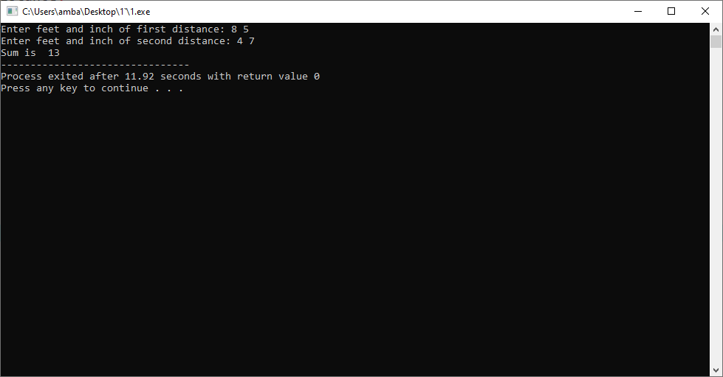

**Practical: 2**

**Aim: Enter the marks of 5 students in Chemistry, Mathematics and Physics (each out of 100) using a Union named Marks having elements roll no., name, chem_marks, maths_marks and phy_marks and then display the percentage of each student.**

**Program:**

#include <stdio.h>

union Marks {

int roll_no;

char name[30];

float chem_marks, maths_marks, phy_marks;

};

int main() {

union Marks marks[3];

for(int i=0; i<3; i++){

printf("Student %d\n",i+1);

printf("Enter roll no. :\n");

scanf("%d", &marks[i].roll_no);

printf("Enter name :\n");

scanf("%s",marks[i].name);

printf("Enter Chemistry marks :\n");

scanf("%f", &marks[i].chem_marks);

printf("Enter Maths marks :\n");

scanf("%f", &marks[i].maths_marks);

printf("Enter Physics marks :\n");

scanf("%f", &marks[i].phy_marks);

}

for(int i=0; i<3; i++) {

printf("Student %d\n",i+1);

float percentage = (marks[i].chem_marks + marks[i].maths_marks + marks[i].phy_marks)/300.0*100;

printf("Percentage : %f\n", percentage);

}

return 0;

}

**Output:**

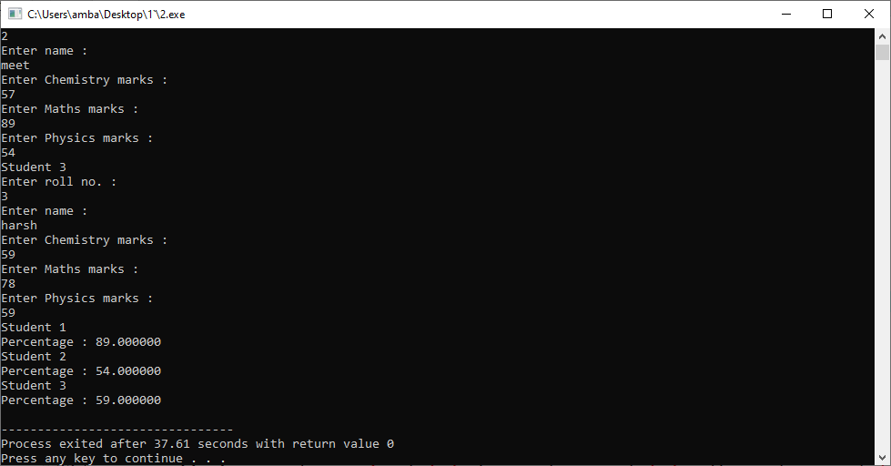

**Practical: 3**

**Aim: Write a program to print integer value of day of week using enum.**

**Program:**

#include <stdio.h>

enum week

{

sunday=1, monday, tuesday, wednesday, thusday, friday, saturday

};

int main()

{

for(int i=sunday;i<=saturday;i++)

{

printf("%d\n",i);

}

return 0;

}

**Output:**

